Defining Classes Labs – Part 1 and Part 2

The system that Jason is looking for, must have the capability of categorizing his data by the following category classes:

Ingredient type

Income source

Unit of Measure

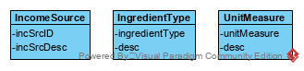

User Story

Eventually, I would like to retrieve total amounts of income for one part of my business. I call this income sources. Right now, I have two income sources, my catering business and the food truck parked at Home Hardware.

Acceptance Criteria:

1. Must be able to query income sources to be able to select income transactions.

|  |  |  |  |
| --- | --- | --- | --- |
| Use Case Name | Create an income source | | |
| Triggering Event | A new source of income (a new business venture) | | |
| Brief Description | Allows the Owner to create an income source | | |
| Actors | Owner | | |
| Related Use Cases |  | | |
| Preconditions | Owner has opened the Main Menu. | | |
| Post Conditions | Income source is added and available to query | | |
| Flow of activities | Actor | | System |
|  |  | Requests to add a new income source | Displays a list of income sources prompting for an income source identifier and description. |
|  |  | Enters income source identifier and description | Verifies that income source identifier and description have been entered  Prompts for confirmation |
|  |  | Confirms entry | Saves the income source and returns to the main menu |
| Exception Conditions | * Owner chooses to cancel adding income source | | |

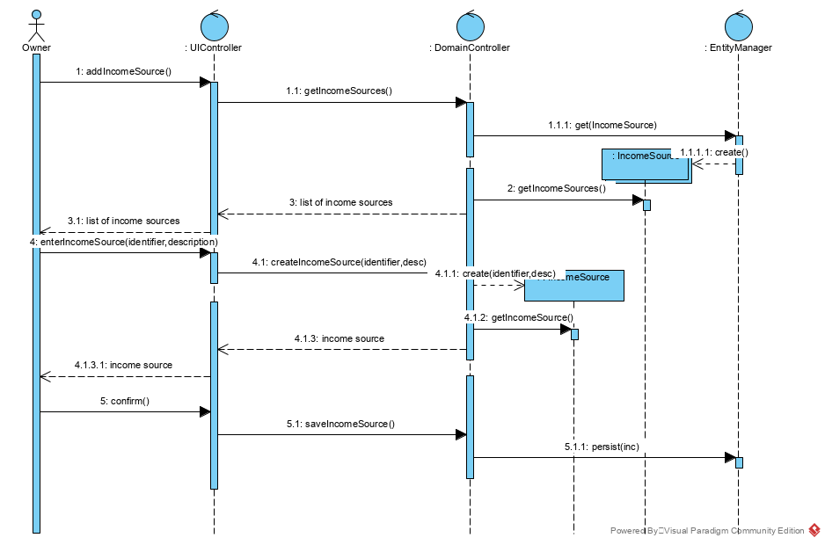

|  |  |  |  |
| --- | --- | --- | --- |
| Use Case Name | Change an Income source description | | |
| Triggering Event | Request to change an income source description | | |
| Brief Description | Allows the Owner to change an income source description | | |
| Actors | Owner | | |
| Related Use Cases |  | | |
| Preconditions | Owner has opened the Main Menu. | | |
| Post Conditions | Income source description is updated | | |
| Flow of activities | Actor | | System |
|  | 1. | Requests to query an income source | Displays a list of income types and prompts for income type. |
|  | 2. | Selects an income type | Retrieves the income type description and prompts for updates |
|  | 3. | Updates description and requests to save | Verifies that description was entered.  Saves the data |
| Exception Conditions | * Owner chooses to cancel updating the income type description | | |

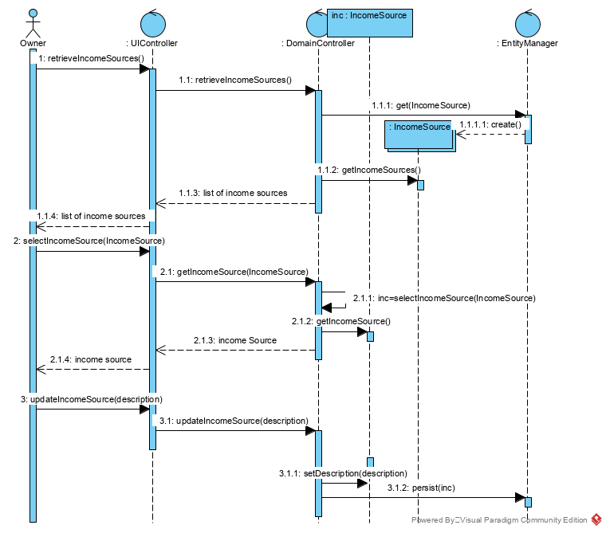

|  |  |  |  |
| --- | --- | --- | --- |
| Use Case Name | Query all income sources and their descriptions | | |
| Triggering Event | Request for income sources | | |
| Brief Description | Allows the Owner to retrieve all income sources and their descriptions. | | |
| Actors | Owner | | |
| Related Use Cases |  | | |
| Preconditions | Owner has opened the Main Menu. | | |
| Post Conditions | All income sources and their descriptions are retrieved. | | |
| Flow of activities | Actor | | System |
|  | 1. | Requests to query all income sources | Displays a list of income sources  Prompts to cancel |
|  | 2. | Chooses to cancel | returns to the main menu |
| Exception Conditions | * Owner chooses to cancel retrieving the income sources | | |

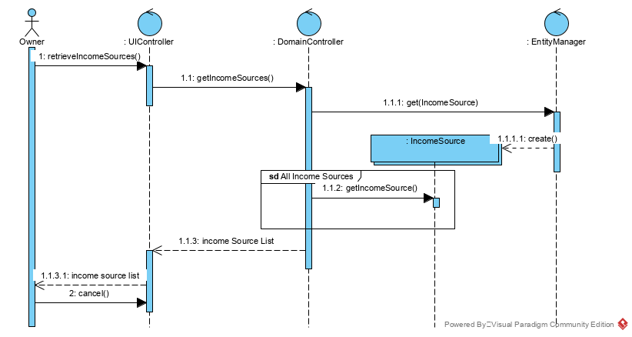

User Story

At this point, the only way that I can tell if my business is profitable is by looking at my bank account. Every once in a while, I calculate the cost of one of my recipes to verify that I’m charging money for my food. Sometimes, you have to have product that doesn’t make as much to encourage customers to buy the ones that do! Eventually, I would like new system to do this for me!

I realize that I need to track the money I spend on ingredients. I also need to record everything in the same unit for measure for my sanity sake!

Acceptance Criteria:

1. Must be able to query units of Measure
2. Must be able to record an ingredient with its unit of measure.

|  |  |  |  |
| --- | --- | --- | --- |
| Use Case Name | Create a unit of measure | | |
| Triggering Event | A new unit of measure | | |
| Brief Description | Allows the Owner to create a unit of measure | | |
| Actors | Owner | | |
| Related Use Cases |  | | |
| Preconditions | Owner has opened the Main Menu. | | |
| Post Conditions | Unit of measure is added and available to query | | |
| Flow of activities | Actor | | System |
|  | 1. | Requests to add a new unit of measure | Displays a list of units of measures and prompts for unit of measure and unit of measure description |
|  |  | Enters unit of measure and description | Verifies that unit of measure and description have been entered.  Prompts for confirmation |
|  |  | Confirms entry | Saves the unit of measure and returns to the main menu |
| Exception Conditions | * Owner chooses to cancel adding the unit of measure | | |

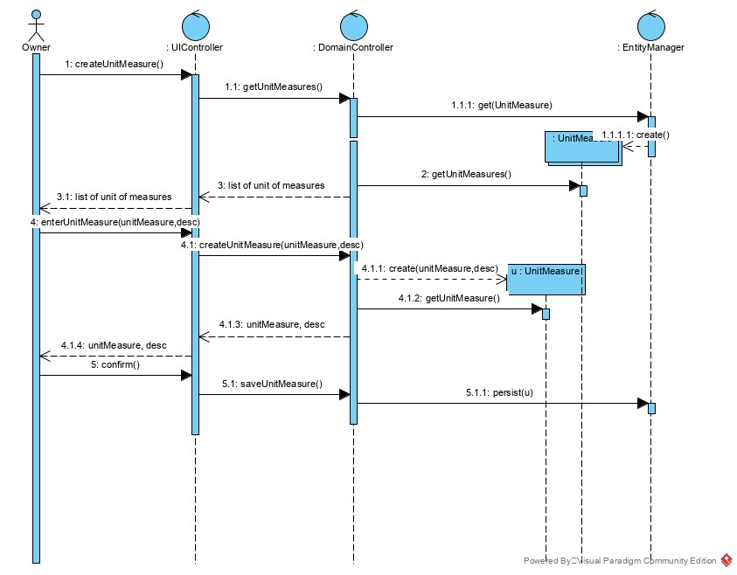

|  |  |  |  |
| --- | --- | --- | --- |
| Use Case Name | Query all units of measure and their descriptions | | |
| Triggering Event | Request for units of measure | | |
| Brief Description | Allows the Owner to retrieve all units of measure and their descriptions. | | |
| Actors | Owner | | |
| Related Use Cases |  | | |
| Preconditions | Owner has opened the Main Menu. | | |
| Post Conditions | All units of measure and their descriptions are retrieved. | | |
| Flow of activities | Actor | | System |
|  | 1. | Requests to query all units of measure | Displays a list of units of measure  Prompts to cancel |
|  | 2. | Chooses to cancel | returns to the main menu |
| Exception Conditions | * Owner chooses to cancel query units of measure | | |

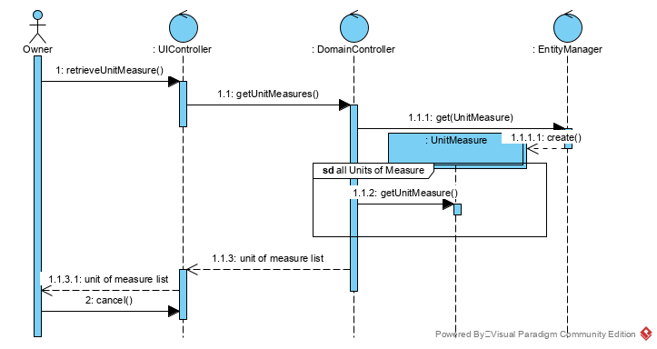

User Story

I’ve found different sources for different types of ingredients. For example, a local bakery has approached me to use their produce in my business as a way of advertising their goods and services. I would like to organize my list of ingredients by ingredient type.

Acceptance Criteria:

1. Must be able to query ingredient types
2. Must be able to record an ingredient with its ingredient type

|  |  |  |  |
| --- | --- | --- | --- |
| Use Case Name | Create an ingredient type | | |
| Triggering Event | A new ingredient type | | |
| Brief Description | Allows the Owner to create an ingredient type | | |
| Actors | Owner | | |
| Related Use Cases |  | | |
| Preconditions | Owner has opened the Main Menu. | | |
| Post Conditions | Ingredient type is added and available to query | | |
| Flow of activities | Actor | | System |
|  | 1. | Requests to add a new ingredient type | Displays a list of ingredient types and prompts for ingredient type and description |
|  |  | Enters ingredient type and description | Verifies that ingredient type and description have been entered.  Prompts for confirmation |
|  |  | Confirms entry | Saves the ingredient type and returns to the main menu |
| Exception Conditions | * Owner chooses to cancel adding the ingredient type | | |

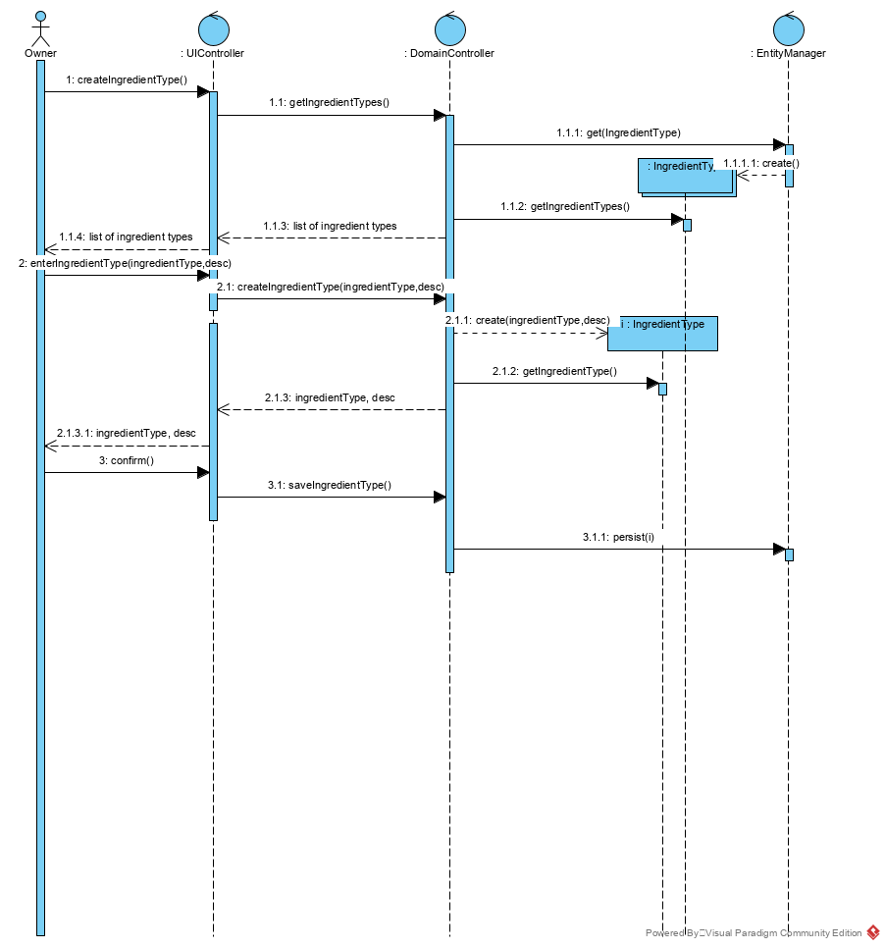

|  |  |  |  |
| --- | --- | --- | --- |
| Use Case Name | Query all ingredient types and their descriptions | | |
| Triggering Event | Request for ingredient types | | |
| Brief Description | Allows the Owner to retrieve all ingredient types and their descriptions. | | |
| Actors | Owner | | |
| Related Use Cases |  | | |
| Preconditions | Owner has opened the Main Menu. | | |
| Post Conditions | All ingredient types and their descriptions are retrieved. | | |
| Flow of activities | Actor | | System |
|  | 1. | Requests to query all ingredient types | Displays a list of ingredient types  Prompts to cancel |
|  | 2. | Chooses to cancel | returns to the main menu |
| Exception Conditions | * Owner chooses to cancel query ingredient types | | |

